Encoding/Media Assignment – Due Tuesday, November 3, 2009

I want you to write up this assignment in a Word doc and send it to me. You will be using your own full name for this assignment and I want you to do it in parts as follows:
- Write out your full name, with spaces between first, middle, and last.
- Write out the equivalent as ASCII code in Hex. This will be two Hex digits per character. Include the spaces between parts of your name and make sure you get the right ASCII code for uppercase and lowercase letters. Hint: you can search the web for an ASCII table, or go to http://www.asciitable.com to get the conversions from Chr to Hx.
- Write out the equivalent binary. This will be four binary digits (bits) per Hex digit. Circle the long sequence of 0’s that are more than 3 in length and do the same for long sequences of 1’s.
- Convert the binary code in #3 to its equivalent 4B-5B code for the entire string in #3. For this you can refer to Table 1-2 (note: one 4B5B code is missing from the table, 1111 → 11101).
  - What can you say about this new string pattern in comparison to that in #3
  - Insert the 5-bit delimiter at the beginning and ending for a part 1 data stream so that I can see all of the bits.
  - How many bits does the new string have?
- Take your first four letters of your last name as an ASCII coded sequence. Write it out as:
  - An 8-digit Hex Code
  - A single decimal (base 10) integer. Hint: use Window’s Calculator accessory (Sci view)
  - How it would appear as an IP address (decimal value of each byte separated by dots)
- For this next problem I want you to write down your telephone number as a 14-character string that includes parenthesis around the area code, a space, and a dash in the usual place. It will have this form: (nnn) nnn-nnnn
  - Write this string out as a 28-Hex digit code for the ASCII equivalent of the 14 characters (see http://www.asciitable.com)
  - Write the equivalent 8B6T code for this. To make it more readable put a space between each 6 character code (which is composed of +, 0, and – symbols). Partial table on next page (which should be fine for the numerals, space, and other characters in this string).
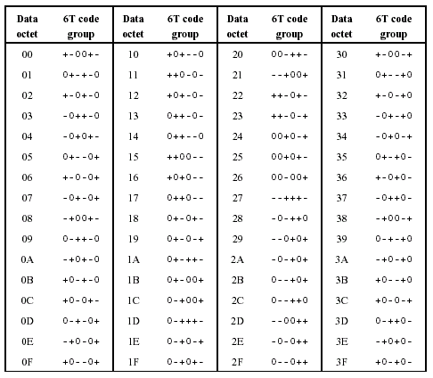
- Finally, I want you to take the same 14-character string (from last problem) and give me the Checksum byte for it. Show all your work for this, or at least show all of the elements (you can do the arithmetic with the Scientific calculator but it is useful to see what you are adding, subtracting, etc, on paper). Since this is a Check Sum byte (i.e., 8-bits) you need to take your 14-character string as the message, converted to 14 ASCII code bytes. The Check Sum byte is what you must add to these 14 in order to get 00 Hex for an answer (all addition being modulo 256). HINT: you just sum each of the bytes (module 256) and subtract that 8-bit result from 256 to get your answer (modulo 256).

