What’s Running?

An Operating System Project by

Donath Thapa

Joshua Bennett

Chris Peckover

User Documentation for What’s Running? 3.0 Beta

Prepared: November, 20 2010

Submitted to: Jim Jones for Operating Systems and Networking

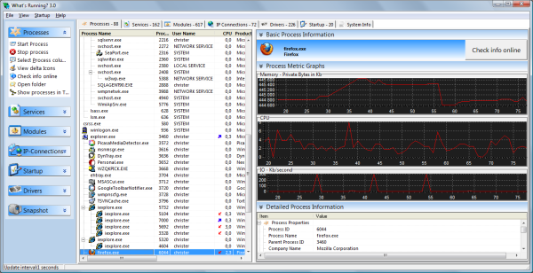
Table of Contents
About 3
Features 3
Download/Install 4
Run the Program 4
Uninstall 4
1. Main Window (Default): 5
2. Working Set Size for a Process 6
3. Page File Usage by a Process 7
4. Network Connections (sockets) a Process has opened 8
5. Checking Thread Count of a Process 8
6. Checking the number of Page Faults of a Process 9
7. File Checksum for a Process 10
8. Find Services working for a Process 11
9. Find Modules (mostly DLL files) used by a Process 12
10. I/O bound or CPU bound 13
11. Disk Drive I/O Activity 14
12. Elapsed Time 15
13. Process Metric Graphs 16
14. Options for Processes 17
15. View More Information 17
16. Update Interval Time and Startup 18
17. Snapshot Feature 18
18. List all current services 19
19. List all current Modules 20
20. List all current IP Connections 21
21. List all Drivers 21
22. List all Startup Processes 22
23. View System Information 23

Table of Figures
Figure 1 Default Main Window 5
Figure 2 Working Set Size 6
Figure 3 Page File Usage 7
Figure 4 IP Sockets Open 8
Figure 5 Thread Count 9
Figure 6 Page Fault per Second 10
Figure 7 File Checksum 11
Figure 8 Services 12
Figure 9 Modules 13
Figure 10 I/O Bound or CPU Bound 14
Figure 11 Disk Activity 15
Figure 12 Elapsed Time 16
Figure 13 Process Metric Graphs Main Window 16
Figure 14 Processes Actions 17
Figure 15 Select Columns 17
Figure 16 Select Columns to View 18
Figure 17 Update Interval 18
Figure 18 Snapshot Options 19
Figure 19 Compare Snapshots 19
Figure 20 All Current Services 20
Figure 21 All Current Modules 21
Figure 22 All Current IP Connections 21
Figure 23 All Active Drivers 22
Figure 24 All Startup Processes 22
Figure 25 System Information 23

About
What’s Running is a product that gives you an inside look into your Windows 2000/XP/2003/Vista/Windows 7 system. What’s Running 3.0 uses a Windows technology called Windows Management Instrumentation (WMI) that has been around for more than 10 years for Windows Operating Systems. It is freely distributed software available at WhatsRunning.net

Features
Processes: Inspect your processes and find all the relevant details that you need! Get performance and resource usage data such as memory usage, processor usage and handles. Also you get all details about what dll(s) are loaded, what services are running within the process and what IP-connections each process has.
IP-Connections: Find out information about all active IP-connections in the system. Get a list of what remote connections each program has and find out what applications are listening for connections.
Services: Inspect what services are running and stopped, find the process for your services and inspect its properties easily!

Modules: Find information about all dll(s) and exe(s) in use in your system. For each module you can find all processes that have loaded the module. Also you can find the full path and immediately open the folder where the file is located.
Drivers: Find information about all drivers, for running drivers you can inspect the file version to find out the supplier of the driver.
Startup: Manage all your startup programs. Disable, edit, delete, and create new easily. Manage startup programs regardless of source (registry or Startup folder).
System information: Show important system information about your computer, such as installed memory, processor, registered user, OS and OS version.

Download/Install
The program is a freeware and can be downloaded from http://www.whatsrunning.net/download.aspx
It is strictly for Windows Operating Systems only. As of November 20, 2010 the latest version of the program is What’s Running 3.0 BETA 9 2010-04-20
The installation file is only 4.46 MB.
The installation requires administrative privileges. Although you may install it as a portable application, to run it you will still need the administrative privileges nonetheless.

Run the Program
Once the installation is a success the files are located in C:/Program Files/WhatsRunning Folder (default). To run the application, open WhatsRunning.exe located inside the folder.

Uninstall
To uninstall it you can run unis000.exe located inside the main folder. (C:/Program Files/WhatsRunning/ is the default) Also, if you installed it as a portable application, simply deleting the program folder is enough.

1. Main Window (Default):
The window is divided into three sub-sections. The left contains actions specific to the tabs selected (Processes, Services, Modules etc.). The middle section contains information about selected tabs. The third section contains other information, graphs and detailed Information section. The “Detailed Process Information” displays a lot of details about all the processes. Process metrics Graphs is a quick look at the overall performance for the machine. There are various tabs that show different sections. Clicking on any of the category heading sorts the list in ascending/descending order. The Window menus are hardly used unless changing options but most other features are accessed through the main window. As you can see in the figure below the CPU tab was used to sort the processes by CPU usage. The process metrics graph shows a nice visual of the performance of the operating system. It is divided into three subjects: Memory, CPU, and I/O. Also notice that the tabs along the top show how many processes or services are running. For example, the “Processes” tab currently shows that there are 64 processes running and the “Services” tab shows that there are currently 171 services open. These numbers will increase/decrease as more programs are run/terminated.
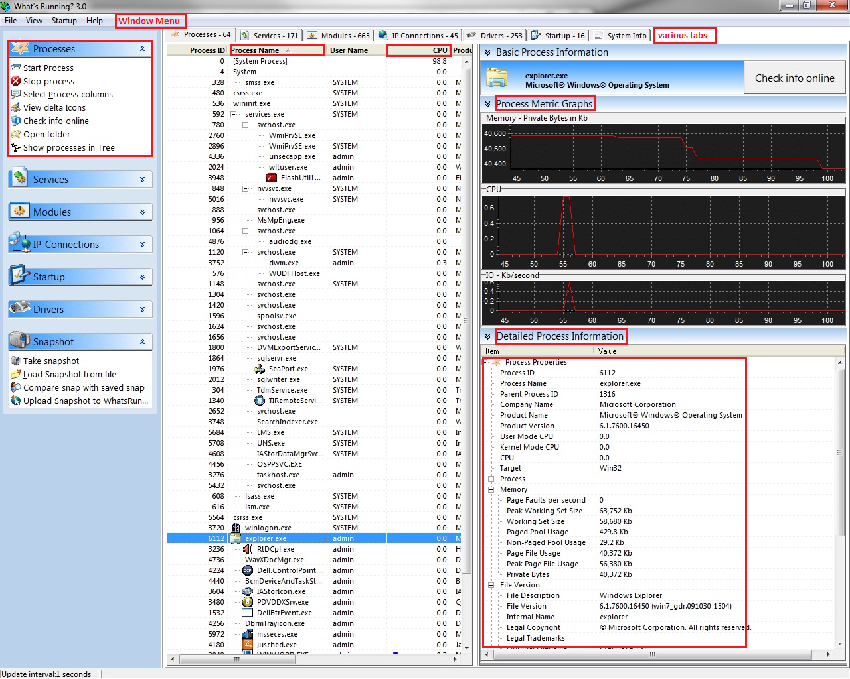
Figure 1 Default Main Window

2. Working Set Size for a Process
The working set of a program is a collection of those pages in its virtual address space that have been recently referenced. It includes both shared and private data. The shared data includes pages that contain all instructions your application executes, including those in your DLLs and the system DLLs. As the working set size increases, memory demand increases. A process has an associated minimum working set size and maximum working set size. The virtual memory manager attempts to keep enough memory for the minimum working set resident when the process is active, but keeps no more than the maximum size. The system sets the default working set sizes but this can be manually set using advanced commands.
- From the main window, select Processes tab
- Select a Process Name (e.g.: iexplore.exe)
- Select the Detailed Process Information on the right
- Expand Process Properties and expand Memory.

In Figure 2 shown on the next page, you will notice that we opened an Internet Explorer browser and that the working set size is just under 22Mb. As you can see below the first iexplore.exe there are also two other iexplore.exe items. These are tabs that are open with the first iexplore.exe item.
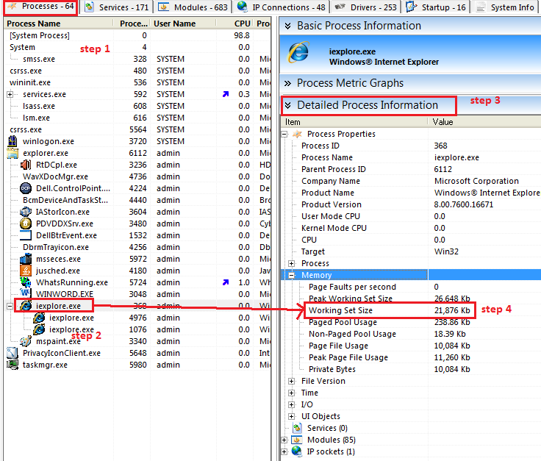
Figure 2 Working Set Size

3. Page File Usage by a Process
The paging file is very closely related to the physical RAM installed in the computer. Its purpose is to extend the amount of physical RAM and make it available to the system. Both services and installed applications can benefit from this 'extra' RAM, even though it is substantially different from the sticks that plug into the motherboard. For example, a computer with 1GB RAM will likely gain in overall performance if the Page file is set to at least 1.5 GB.
Working set size for that process is located in the third row.
- From the main window, select Processes tab
- Select a Process Name (e.g.: iexplore.exe)
- Select the Detailed Process Information on the right
- Expand Process Properties and expand Memory. Page File Usage for that process is located in the third row.

In this image you can see that we selected csrss.exe as our process. From there we selected the detailed process information tab on the right and then under “Process Properties” we selected “Page File Usage”. As you can see the Page File usage of this process is over 2800 Kb. It also shows the Peaked File Usage at 2980 Kb.

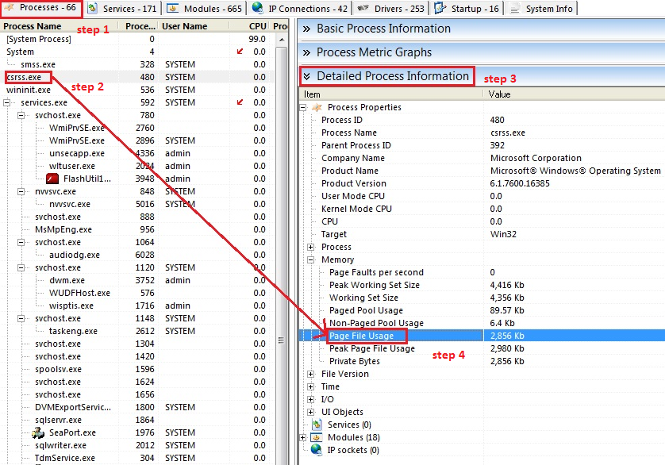
Figure 3 Page File Usage

4. Network Connections (sockets) a Process has opened
A network socket is an endpoint of a bidirectional inter-process communication flow across an Internet Protocol-based computer network, such as the Internet. Each socket is mapped by the OS to a communicating process or thread. A socket address is the combination of an IP address and a port into a single identity. Basically, if your process is communicating with other processes across a network, that process will open all the appropriate sockets necessary. This tool is especially helpful to verify the integrity of a process.
- From the main window, select Processes tab
- Select a Process Name (e.g.: iexplore.exe)
- Select the Detailed Process Information on the right
- Expand IP Sockets. There are different IP Sockets listed under IP Sockets. Expand each to see the details.

In this figure the process we used iexplore.exe as our process. On the right under IP sockets it shows the sockets state as close_wait. It also shows all of the other details about the socket such as the creation time and its local and remote IP addresses. It also shows that the socket type of this process is TCP/IP. It also reflects the computer that we used which in this instance was csLab14.
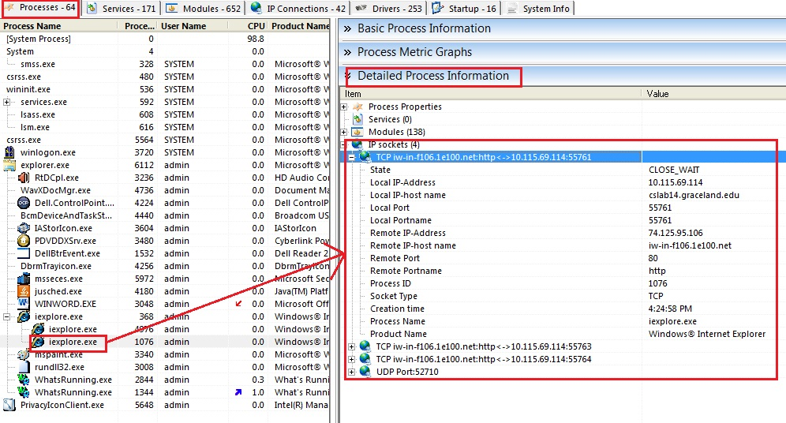
Figure 4 IP Sockets Open

5. Checking Thread Count of a Process
A thread is a flow of execution through the process’s code, with its own program counter, system registers, and stack. Usually large processes create numerous threads (mini processes).
- From the main window, select Processes tab
- Select a Process Name (e.g.: iexplore.exe)
- Select the Detailed Process Information on the right
- Expand Process Properties and Process. The third row is the Thread Count value.

This image shows the process explorer.exe and the arrow is pointing to the thread count which is 35. Below thread count is the base priority which defines the priority given to this thread. In this case it is an 8 which is normal. This can range from low to high. The handle count is 928.

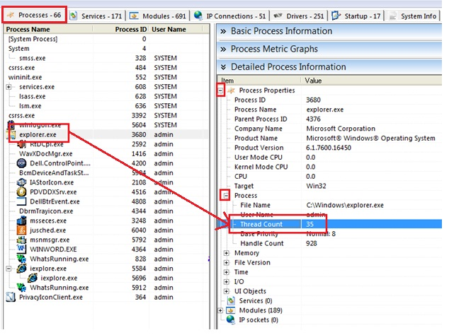
Figure 5 Thread Count

6. Checking the number of Page Faults of a Process
A page fault is a trap to the software raised by the hardware when a program accesses a page that is mapped in the virtual address space, but not loaded in physical memory. Page faults by their very nature degrade the performance of a program or OS and cause thrashing.
- From the main window, select Processes tab
- Select a Process Name (e.g.: iexplore.exe)
- Select the Detailed Process Information on the right
- Expand Process Properties and Memory. The first row is the Page Faults per second value.

In this figure you can see that we did not select a single process but the system process. On the right hand side you may notice that there are 1718 page faults per second. The more page faults there are the lower hit ratio a process will have. The peak working size is just over 1.8 GB. The working set size is at 1.2 GB so it is not far off from the peak. The computer that we ran this on had 4 GB of real memory.
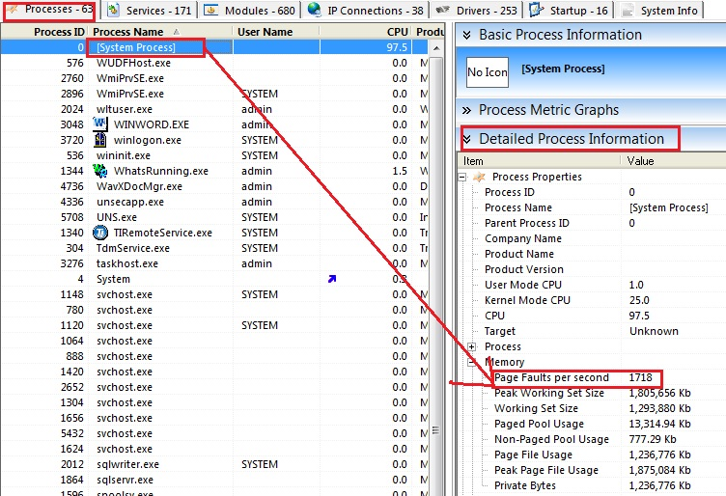
Figure 6 Page Fault per Second

7. File Checksum for a Process
A checksum or hash sum is a fixed-size data computed from an arbitrary block of digital data for the purpose of detecting accidental errors that may have been introduced during its transmission or storage. The integrity of the data can be checked at any later time by re-computing the checksum and comparing it with the stored one. If the checksums match, the data was almost certainly not altered (either intentionally or unintentionally). In the figure below the checksum is shown as 0008316.
- From the main window, select Processes tab
- Select a Process Name (e.g.: iexplore.exe)
- Select the Detailed Process Information on the right
- Expand Process Properties and expand File Version. The third last row under that should be File Checksum value.
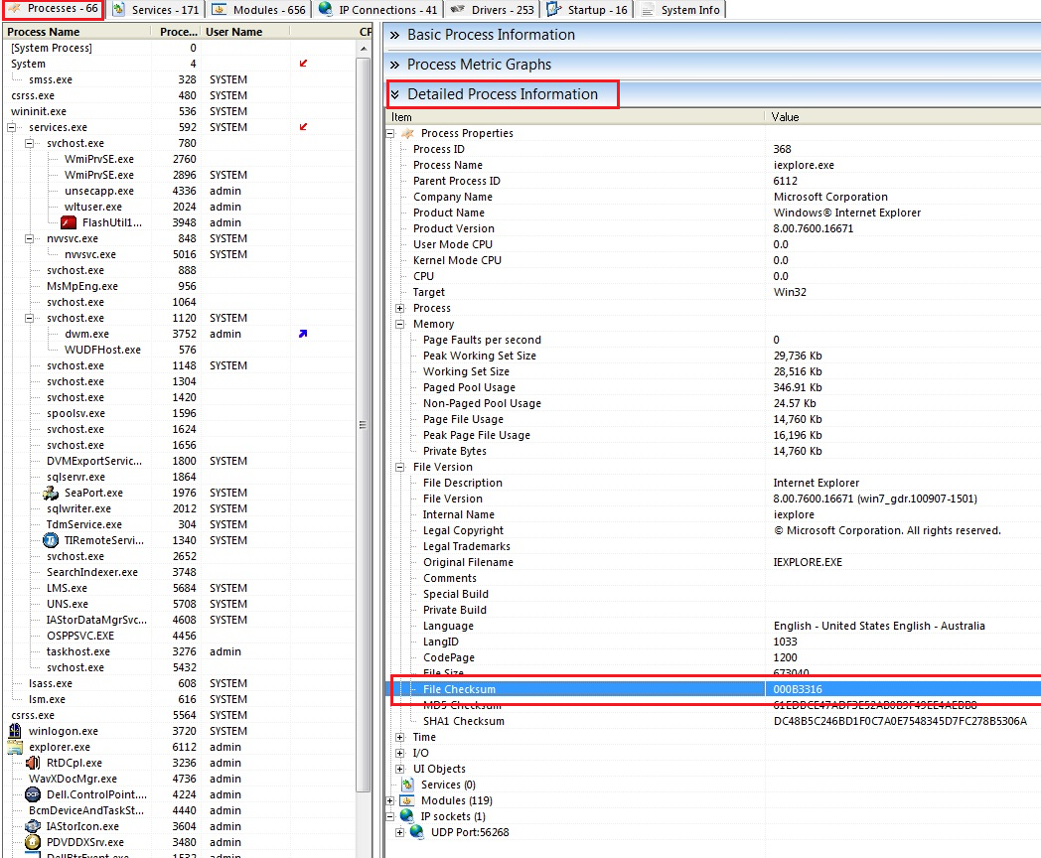
Figure 7 File Checksum

8. Find Services working for a Process
A Windows service is a long-running executable that performs specific functions and which is designed not to require user intervention. Services can start when OS is booted and run in the background. They can also be started manually.
  - From the main window, select Processes tab
  - Select a Process Name (e.g.: iexplore.exe)
  - Select the Detailed Process Information on the right
  - Expand Services. You can expand each of these services for more details.

The process svchost.exe is selected on the left hand side and then under “Detailed Process Information” on the right we can see that Windows Audio is one of the services that it is using. It also gives information such as the Process ID (1064) and also the Service type (Shared). It also gives information such as Display Name and Description.
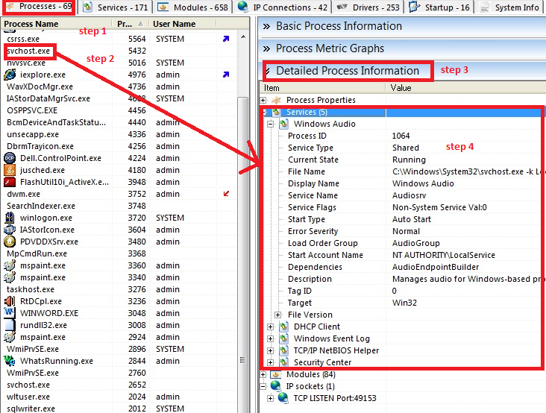
Figure 8 Services

9. Find Modules (mostly DLL files) used by a Process
A process module represents a.dll or .exe file that is loaded into a particular process. A Process Module instance lets you view information about a module, including the module name, file name, and module memory details. A process can load multiple modules into memory. For example, exe files that load additional dll files have multiple modules. After starting the process, this collection is empty until the system has loaded the process.
- From the main window, select Processes tab
- Select a Process Name (e.g.: iexplore.exe)
- Select the Detailed Process Information on the right
- Expand Modules. You can expand each of these modules for more details.
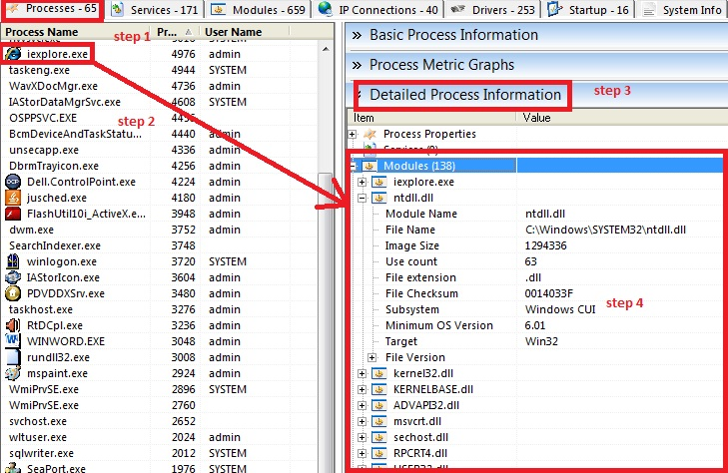
Figure 9 Modules

10. I/O bound or CPU bound
I/O bound refers to a condition in which the time it takes to compete a computation is determined principally by the period of time spent waiting for input/output operations to be completed. This is the opposite of a task being CPU bound.
- Click on processes and click on any process.
- Go to Detailed Process (on the right) and open Process Properties (If not already opened) and I/O.
- If I/O data is closer to 0, then the task is probably not I/O bound. Also, you can go to the process list and click on CPU at the top. This arranges the processes by CPU usage and will help to indicate whether the process is CPU bound or I/O bound.

In this image you can see the process we selected is WhatsRunning.exe, under Detailed Processes on the right you can view the Process Properties. Then under that you can select I/O. As you can see the read and write operations per second are 0, which means that the process is not I/O bound.
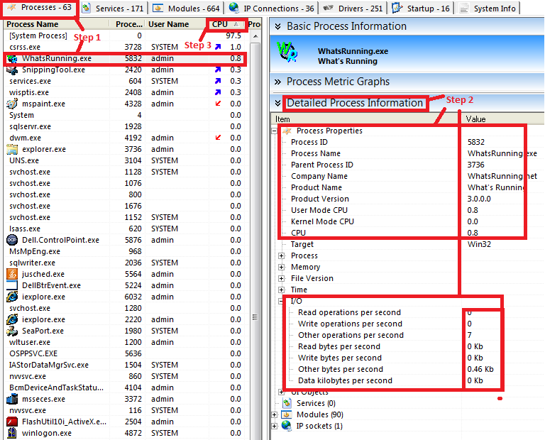
Figure 10 I/O Bound or CPU Bound

11. Disk Drive I/O Activity
Disk Drive I/O activity increases if a process is constantly reading/writing data into a storage medium.
- Do steps 1 and 2 of section “I/O bound or CPU bound”
- Look at the last four rows of the I/O section beginning with “Read bytes per second”. If the values are greater than 0 then there is disk activity.

This figure shows that there are 0 read or write operations of Whats Running. These numbers would change if you were actually inputting information such as using notepad. We used notepad to experiment with this. As you type information the read operations would go up and when you save the document you will see the write operations increase. There are more fluctuations in these I/O variables if the process is more dynamic rather than static.
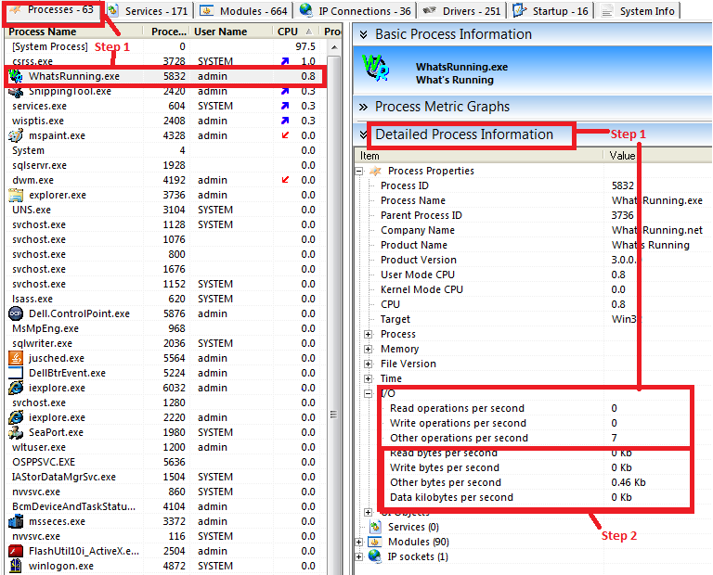
Figure 11 Disk Activity

12. Elapsed Time
- Click on Processes and click on any process.
- Go to the detailed Process Information tab on the right and click on Time.
- The elapsed time that the process has been running will show up.

This image shows that WhatsRunning.exe has been running for 57:22. This would increase the longer you ran the process. You can use this to analyze how stable a process is as time elapses. This would be specifically useful to assess downtimes of server processes.
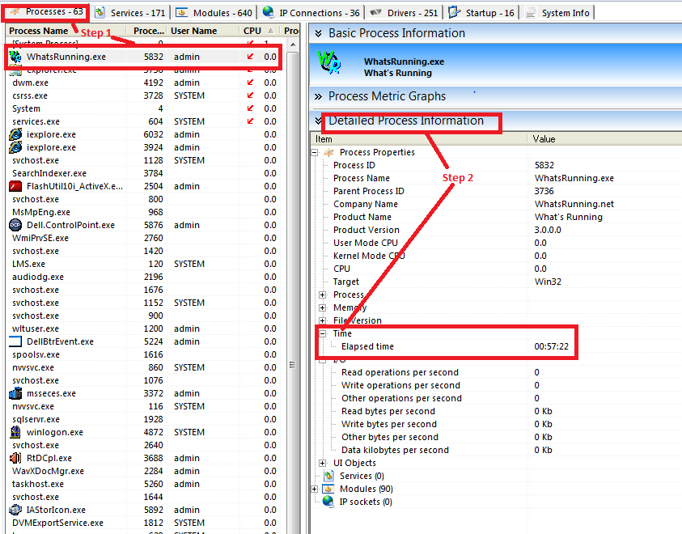
Figure 12 Elapsed Time

13. Process Metric Graphs
Another nice feature about this program is the visual graphs it can give you for each task. In this example we are looking at the process graphs for internet explorer. Under the “Process Metric Graphs” tab under the Processes tab, you can see three different graphs. The first one is for memory, and it shows how many bytes (in Kb) are being used by the task. The second graph shows the CPU and the third graph is for Input/Output.
Figure 13 Process Metric Graphs Main Window

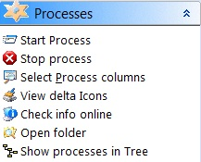
14. Options for Processes
- You can start a process by selecting “Start Process” and browsing to the process.
- You can stop a process (WARNING: Terminating a process can cause undesired results including loss of data and system instability. The process will not be given the chance to save its state or data before it is terminated.)
- “View Delta Icons” shows when a CPU usage is up or down using two up and down arrows.
- “Check info online” allows a user to find detailed information about a process online if that process is saved in the database (http://www.whatsrunning.net/processinfocentral.aspx) A better and more comprehensive library exists at http://www.processlibrary.com
Figure 14 Processes Actions
- “Open Folder” shows the folder where the process is saved.
- “Show processes in Tree” switches between a hierarchical and a straight list views for all processes. Hierarchical view shows the interconnectedness between processes and is recommended.

15. View More Information
- To view more information about processes, services, modules, IP connections and Drivers choose “Select XXX Columns” from the View drop down menu, where XXX may represent process, service, module, IP connections or drivers.
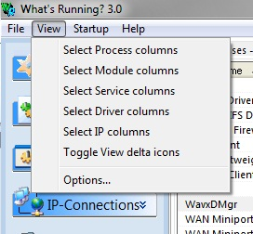
Figure 15 Select Columns
- Select columns to display. The options are with respect to what was selected.
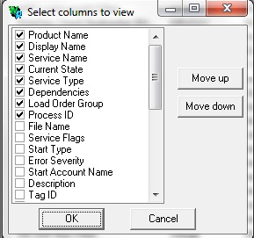
Figure 16 Select Columns to View

16. Update Interval Time and Startup
- Select “Options” from the View menu drop down.
- Under the Update tab, select update interval times. 1 Second is default.
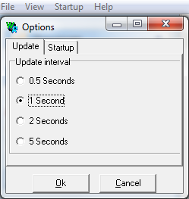
Figure 17 Update Interval
- Under the Startup tab, you can select to run What’s Running 3.0 instead of Task Manager.

17. Snapshot Feature
Whats Running also has a snapshot feature. You can access this feature on the bottom of the left hand panel. From there you have four options. (1) Take a snapshot (2) Load a snapshot from a file (3) Compare a snapshot with a saved snap (4) Upload Snapshot to WhatsRunning.net

- The “Take snapshot” feature will capture every process and statistic that is running on your system at the current time. You can save the snapshot and it will be dated and time stamped so you know when you took it.
Figure 18 Snapshot Options
Figure 19 Compare Snapshots
- You can also load a snapshot from a previously saved file. This way, if you ever were wondering about the stats of a certain task from a certain time then you could look it up.
- The compare feature is also very useful. Here you can bring up two previously saved snapshots and look at various information about your system from different times.
- You can also upload a screenshot to WhatsRunning.net to share information with others or ask questions.

18. List all current services
- From the main window, select Services tab. You can explore the service names, processes that are using those services, current states and service types. To see more, go to section “View More Information”.

Services like “windows audio” do not need to be instantiated every time a process needs it to run, it can borrow it from the operating system.
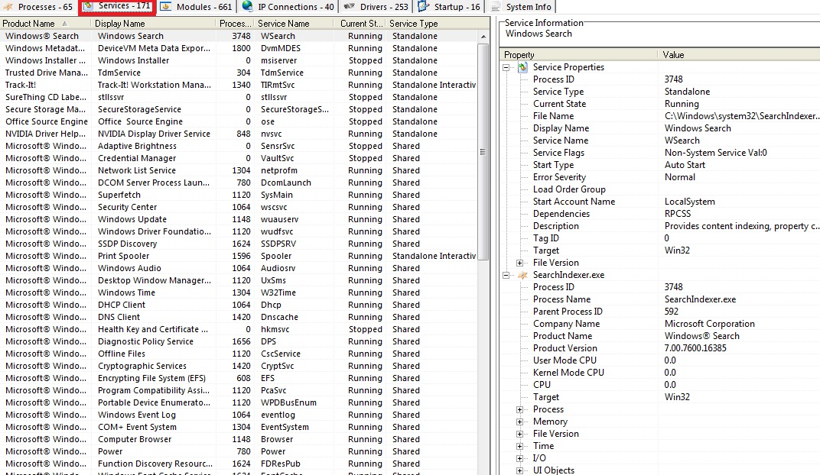
Figure 20 All Current Services

19. List all current Modules
- From the main window, select Modules tab. You can explore the module names, location, image size, use count and file version. To see more, go to section “View More Information”.

In this figure you will notice that all of the modules are .dll files. DLL stands for dynamic-link library which is a shared library used by all of the processes to reduce overhead. It is best to maintain the latest versions of these .dll files; you can check the file version by looking at the 7th column in the figure below. The module name ntdll.dll (NT layer DLL that contains NT kernel functions) is the one that is used most with a use count of 61.

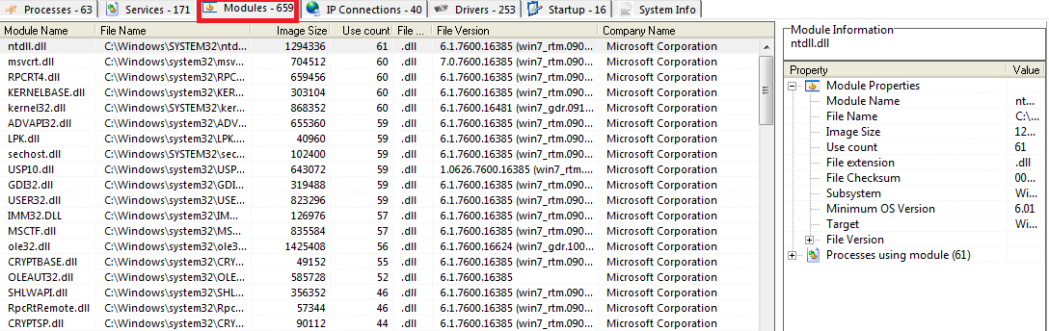
Figure 21 All Current Modules

20. List all current IP Connections
- From the main window, select IP Connections tab. You can explore the socket type, Local IP-host name, state, remote IP-host name, remote IP-Address, local port, local IP-Address and creation time. To see more, go to section “View More Information”. For more details please see the sockets section (section 4).
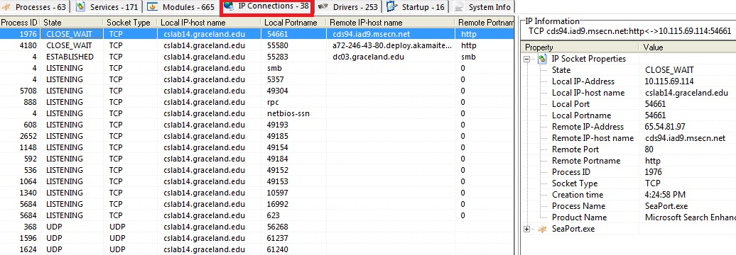
Figure 22 All Current IP Connections

21. List all Drivers
- From the main window, select Drivers tab. You can explore the name, current state, type, load order group and product name. To see more, go to section “View More Information”. A device driver or software driver is a computer program that allows programs of a higher level to interact with a hardware device. If your device drivers are up to date then the operating system will typically perform better. This will allow you to use your devices to their utmost capabilities.
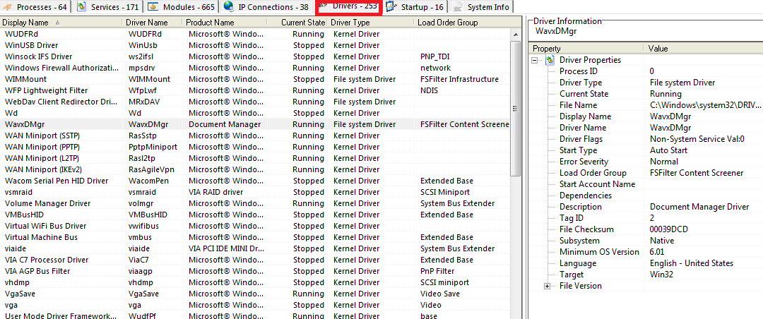
Figure 23 All Active Drivers

22. List all Startup Processes
- From the main window, select Startup tab. You can explore the name, path, run state, type and enabled status. Disabling unnecessary startup files would make the system boot up faster and allow resources for more critical tasks.
To get your computer to boot most efficiently, you could remove unnecessary start up items from this list.

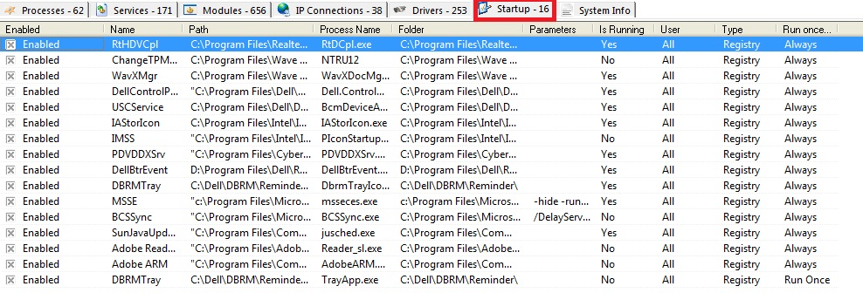
Figure 24 All Startup Processes

23. View System Information
- From the main window, select System Info. You can view crucial information regarding the computer and its OS here.

As you can see in this figure, this was the csLab14 which is running a Windows 7 operating system. You can also view information such as processor type and the amount of physical memory. It will even tell you where the operating system is created (United States) and also which time zone the clock is set for (Central). This gives you all of the basic information about the operating system that you are running.
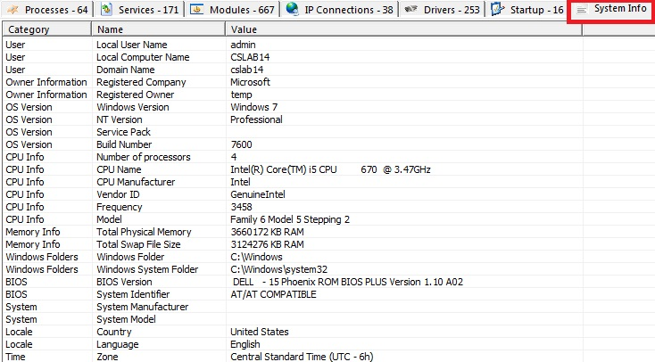
Figure 25 System Information

